
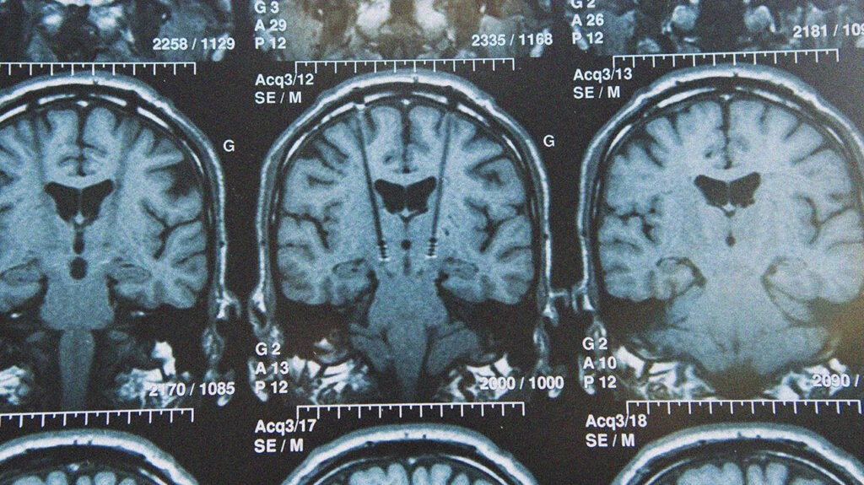

Participants with low mood wanted for brain stimulation study
Study: Effect of iTBS on emotional processing

Researchers at the Department of Psychiatry, University of Oxford are seeking right-handed volunteers aged 18-45 years with symptoms of low mood for a Transcranial Magnetic Stimulation (TMS) study.

The purpose of this study is to improve treatment for people suffering from depression and test if novel brain stimulation changes emotion recognition.

Transcranial Magnetic Stimulation (TMS) is a form of neurostimulation that generates a magnetic field that passes painlessly through the skull to stimulate the brain. Participants may experience some mild temporary discomfort during TMS.

This study involves four visits to the Oxford Centre for Human Brain Activity at the Department of Psychiatry, University of Oxford or FMRIB at the WIN centre, John Radcliffe Hospital. Two sessions will take no more than 90 minutes and two sessions will take no more than 3 hours.

We will compensate you for your time, performance and reasonable travel costs for every session (including the online screening session via MS Teams).

If you are interested in participating in this study and/or would like further information, please contact Daniel Graham at daniel.graham@psych.ox.ac.uk.

