Investigating mechanisms underlying psychosis in the human brain
Are you interested in volunteering for a brain scan study?

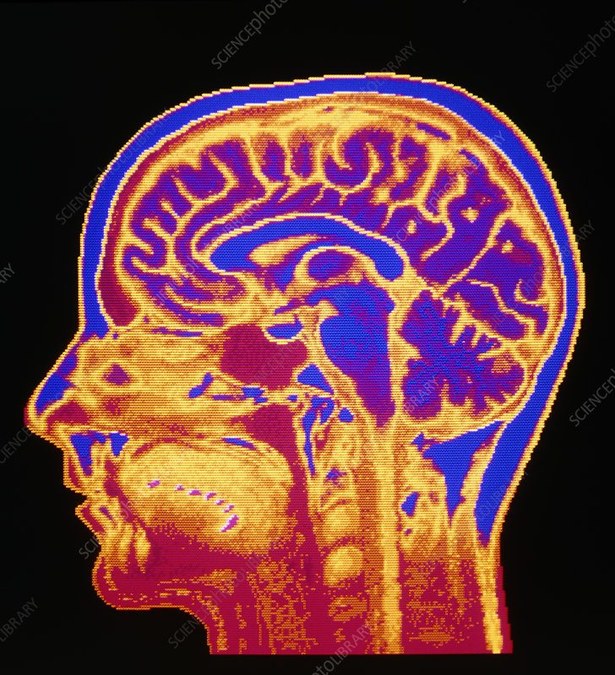

We are looking for male participants between the ages of 18 and 30 who are healthy and have no history of Psychosis. The aim of the study is to investigate how changes in brain activity underlie psychosis. This study involves several behavioural tests and questionnaires as well as a brain scan using Magnetic Resonance Imaging (fMRI, 7T) and/or Magnetoencephalography (MEG). These types of brain scans allow us to see how the brain is organised, processes information and performs skills like speech or memory. These scans are safe and do not involve any needles or injections.

For information in confidence, with no obligation to participate, please contact:

Leonie Glitz at leonie.glitz@bndu.ox.ac.uk

Participants will be reimbursed for their time and expenses at a rate of £15/h

