Building stress resilience in early adolescents’ lives BReal

Worksheet: Lesson 3 “Changing our Stress Response”

Lesson 3 Baseline: Student Questionnaire

By yourself, indicate to what extent you agree with each of the statements by ticking or circling the corresponding box on the grid. Your answers should reflect your honest opinion about each statement.

|  |  |  |  |  |  |
| --- | --- | --- | --- | --- | --- |
| Statement 1:  “We are born able to cope with stress and with practice we can keep getting better” | Strongly disagree | Disagree | Undecided | Agree | Strongly agree |
| Statement 2:  “Understanding how our brains are developing in adolescence can help us build our own and our friends’ stress resilience” | Strongly disagree | Disagree | Undecided | Agree | Strongly agree |

**3.** Personal actions can make a big difference to mental well-being: think of as many ways you can that could reduce someone's stress.

**4.** Give 3 examples of ways in which groups of friends can stress each other and 3 examples of ways they can support each other.

Stress Bucket Activity

In groups, discuss and answer the two stress bucket questions below. What are things that fill up people’s stress buckets? What are ways to help reduce stress?

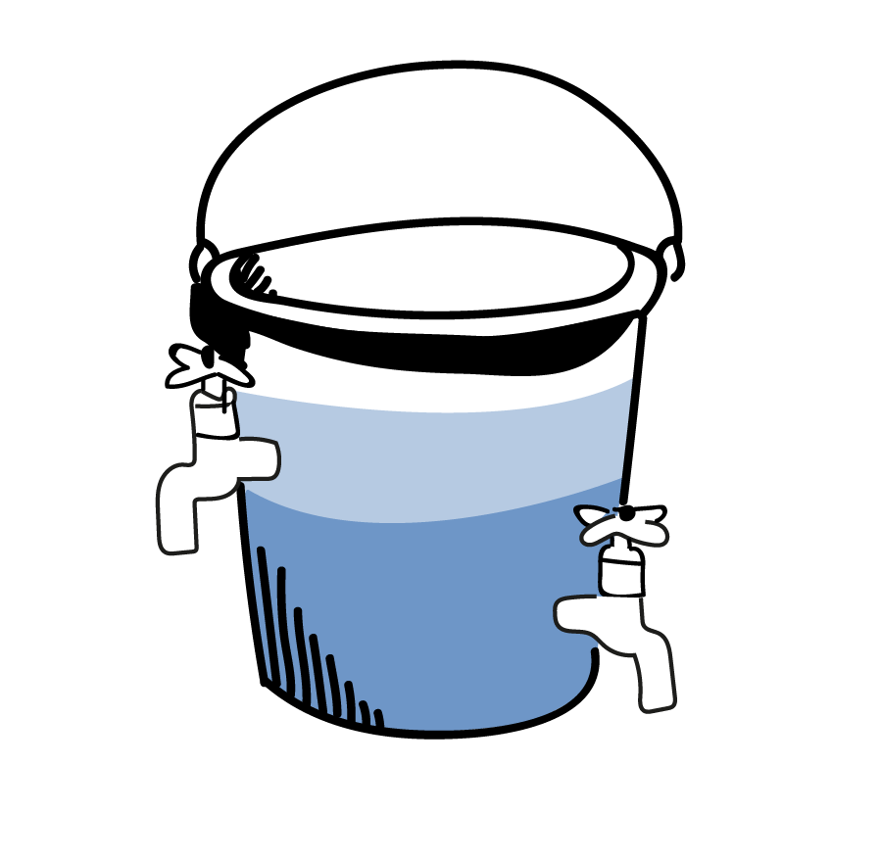

Some ways to help stressors go away are…

Things that fill up people’s stress buckets are…

Case studies

|  |
| --- |
| Do you remember **Amber**? She worries a lot about friendships and what other people think of her. She would really like to be in the school production but worries about trying out for it. Amber has a couple of friends and talks to them about taking part in the auditions. One of her friends offers to audition with her. The day before the audition, they go to check out the room, so they know where it is going to take place. They also practice their audition to their other friend, who lets them know how impressed she is that they are going to audition. Their other friend also reminds them that not everyone has the guts to do this. When it comes to the audition, Amber is nervous. Instead of focusing on her worries about what could go wrong, she focuses on the words of the song. She knows that she just needs to give it a go to be in with a chance. |

|  |
| --- |
| Do you remember **Kai**? He often feels stressed about school. Sometimes he feels like a failure and can’t think of anything positive about himself. He thinks about what he can do to manage his stress and feel better. He really wants to do well at school, so has a think about what could help him with feeling less stressed about school. He starts by planning to try to do his homework the day it’s set and to make a list for what he needs each day for school and to pack his bag the night before. To help him with feeling a bit down, he also identifies what things matter to him and make him feel good. He really enjoys skateboarding but hasn’t been to the skatepark much over the last few months. He decides to go to the skatepark a couple of times a week after school with some friends. He also loves animals and so plans to ask a neighbour if he can take their dog for a walk at the weekend. A couple of months later, he notices that he’s feeling less stressed and much happier. |

Remember Joe and Tia from Lesson 1? What could they learn from Kai and Amber?

|  |
| --- |
| **Joe** is in Year 7. He has been best friends with Maisie since primary school. He was pleased (and relieved) when he was put in the same form as Maisie at secondary school. Joe has begun to feel worried that Maisie doesn’t want to be his friend anymore. He feels that Maisie isn’t talking to him as much and is leaving him out of chats and activities with other people. He has tried telling Maisie how much this upsets him, but this just seems to cause arguments. He has suggested that they spend more time together just the two of them. He feels like he can’t do anything right and just wants his old friend back. |

|  |
| --- |
| **Tia** is in Year 8. She loves athletics and playing football. She does sport at school and plays football for a local club. Tia is small for her age and some of the girls she plays football with are now quite a bit taller and stronger than her. Sometimes this makes it hard for her to out-run them or get the ball in a tackle. Recently Tia hasn’t been picked for the first team or has been substituted in a game, which has been frustrating, and she has wondered whether she should just give up playing. The other evening, she couldn’t face going to football and instead said to her mum that she felt too ill to go. |

Personal Reflection

This exercise is just for your reflection, you will not need to share your responses.

**Individual**

Here is an example based on Joe: Joe has always loved rollerblading and in his local town, a roller disco has recently opened. Joe has wanted to go but was nervous that he might see someone from school there. His cousin comes over for the weekend and they decide to be brave and give it a go. You can see how Joe got on in the table below.

|  |  |  |  |  |  |
| --- | --- | --- | --- | --- | --- |
| Date/  Time | Action | How did you feel before you started | How did you feel afterwards | Did anything that you were worried about beforehand actually happen | Do you think this could be a good stress bucket tap in the future? |
| Wed,  8am | Go to a roller disco with my cousin | Scared and worried that someone would see and think it was a stupid idea | Brilliant! I loved it, apart from when I fell on my bum! | I did see someone from school, but they seemed to be having fun and waved at me. It didn’t look like they thought it was a stupid thing to do! | Yes, and I think if I invited a few, new friends to come next time we could enjoy it together and it would help me get to know them better. |
|  |  |  |  |  |  |

**Social**

Below is an example based on Amber: Amber’s friend, Tasha, wants to support Amber to achieve her goal of auditioning for the school production. You can see how Amber got on in the table below.

|  |  |  |  |  |  |
| --- | --- | --- | --- | --- | --- |
| Date/Time | What was your friend stressed about? | What did you do to help? | How did they feel afterwards? | How did you feel afterwards? | How did it go?  /What happened next? |
| Wed, lunchtime | My friend Amber really wants to audition for the school production but is worried about messing up and being judged. | We went to the music rooms at school, and she practiced her audition in front of me. | She felt pleased she did it and more confident for the actual audition. | I felt good that I had supported her and helped her feel more confident. | She was nervous to begin with, and we kept laughing. But then she did it properly and it was really good.  She’s signed up for the auditions so hopefully she’s going to go for it! |
|  |  |  |  |  |  |

Set yourself a challenge to do over the next week or so. Is there an activity that you’ve been avoiding, maybe because you’re afraid what friends might think about it, but you secretly think it might actually be fun to do? By having a go at it, you can overcome your amygdala that tells you all the reasons why you shouldn’t do it, build new brain flexibility by trying out something new, and maybe add a new tap to your stress bucket. Don’t let your amygdala have you miss out on new experiences, just because its job is to warn you of what the social consequences could be. Afterwards, add your own experience in the line below Jo’s in the chart above, based on how you felt about your own personal challenge.

**My Personal challenge is …**

Uplift a friend (support their prefrontal cortex) and help them build up their resilience. Note in the table above (under Amber’s example) what you did and how it went.

*Remember, practice will grow the connections within and between the amygdala that signals the stress response and wants to keep you safe, and the prefrontal cortex, that helps you deal with social environments and wants you to try new things and learn though mistakes.*

Lesson 3 Endpoint: Student Questionnaire

By yourself, indicate to what extent you agree with each of the statements by ticking or circling the corresponding box on the grid. Your answers should reflect your honest opinion about each statement.

|  |  |  |  |  |  |
| --- | --- | --- | --- | --- | --- |
| Question 1: “Stress is always bad” | Strongly disagree | Disagree | Undecided | Agree | Strongly agree |
| Question 2: “Mistakes are always bad” | Strongly disagree | Disagree | Undecided | Agree | Strongly agree |

**Question 3:** One of your friends is feeling stressed and worried about a test. What could they do that would help? List 3 ideas below:

**Question 4:** What are some other strategies explored in these lessons that someone could try if they were feeling stressed?

Key messages of Lesson 3

1. We are born able to cope with stress and with practice we can keep getting better.

2. Understanding how our brains are developing in adolescence can help us build our own and our friends’ stress resilience.

3. Personal actions can make a big difference to mental well-being.

4. Friends can cause us stress but also help us reduce our stress.

***This is the end of the lesson material for BReal: Building stress resilience in early adolescents’ lives. We hope you have found the information and exercises useful, and will continue to incorporate what you learned going forward in your life. From all of us on the BReal team at the University of Oxford, we wish you well!***

